Task 6 – Mean Variance Efficient Frontier – Investable ETF Proxies
In this section, we construct Mean Variance (MV) efficient frontier using investable ETF as practical proxies to assess whether the similar efficiency can be achieved using ETF in real-world. Academic factor portfolios are typically constructed as long-short strategies designed to isolate systematic risk premia (Fama and French, 1993 (FF3); Fama and French, 2015). However, such strategies are not directly investable for most portfolio manager due to short-selling requirements, leverage constraints and high turnover. So, we compute the theoretical factor portfolios with liquid and long-only ETF proxies here.
The ETF proxies used are summarised in table 4.
Factor | Paper Portfolio | ETF Proxy | Ticker
Market | Mkt-RF | S&P 500 | SPY
Size | SMB | Russell 2000 | IWM
Value | HML | Russell 1000 Value | IWD
Profitability | RMW | Quality Factor | QUAL
Investment | CMA | Minimum Volatility | USMV
Table 4: Investable ETF proxies for FF factors
All ETF returns are converted to excess returns to be consistent with FF factor series, reported in excess return format.

Efficient Frontier Estimation
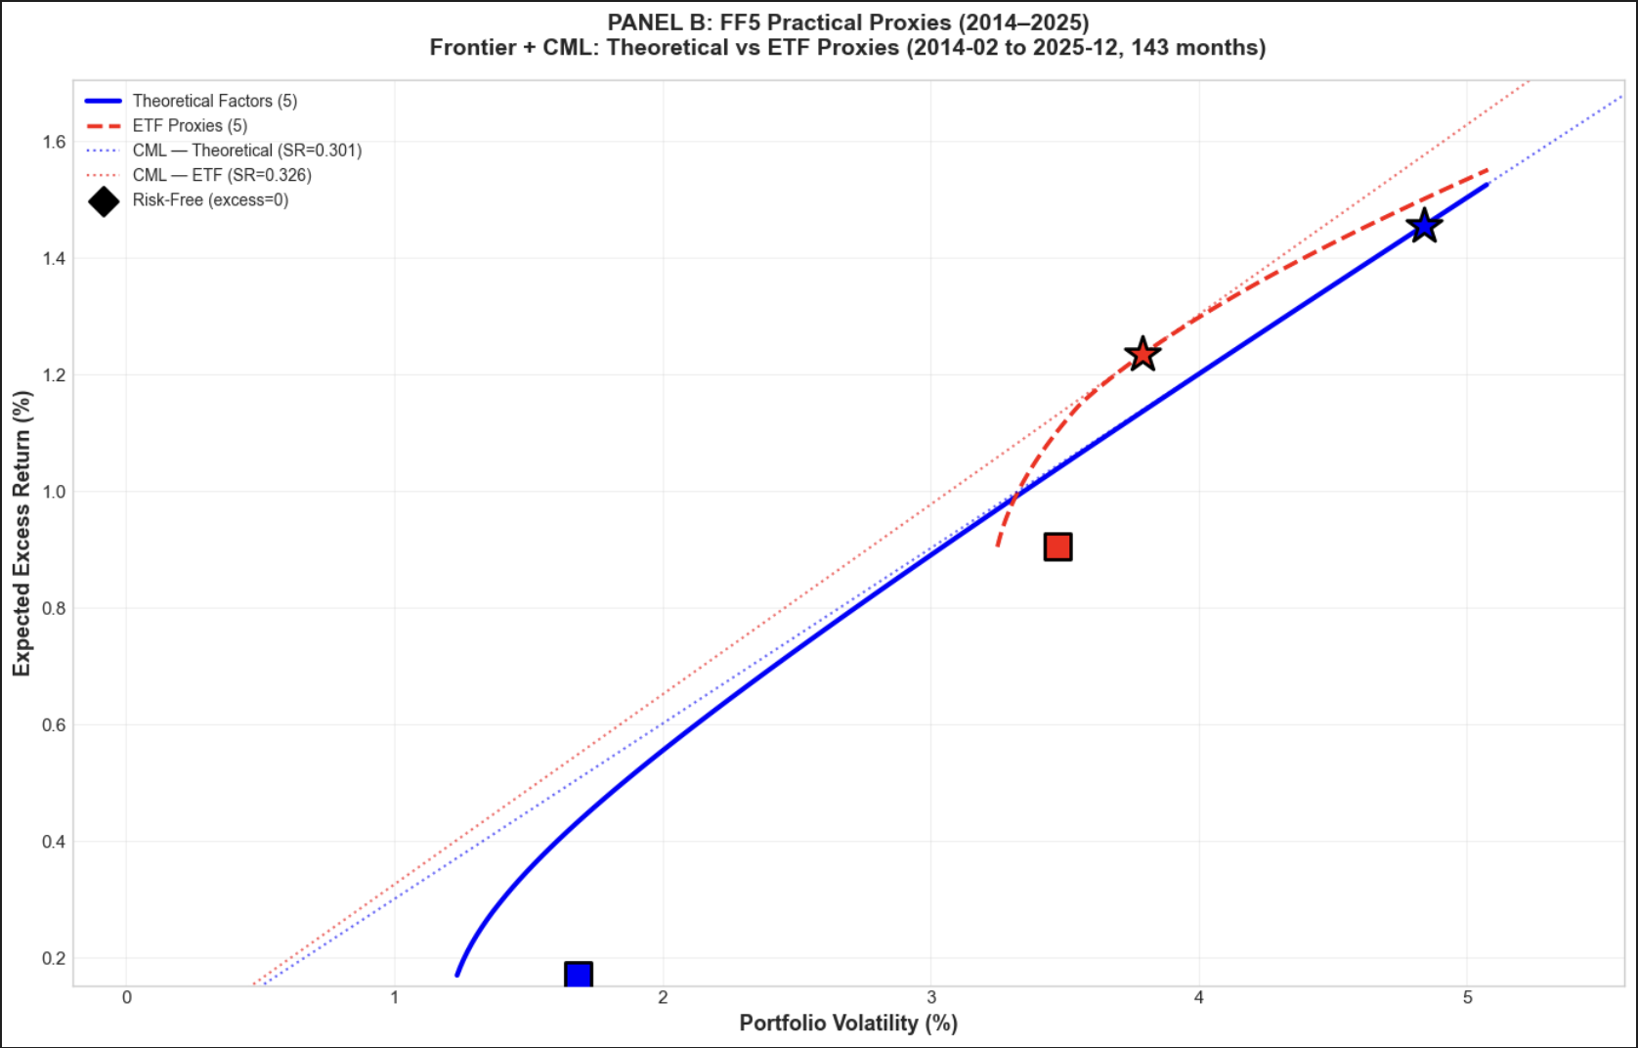
Figure 3: Theoretical Factors vs Investable ETF Proxies (143 observations, February 2014 – December 2025)
In figure 3, the theoretical frontier (blue) lies outward relative to the ETF frontier (red), indicating a superior risk-return trade-off. For a given level of volatility, the theoretical portfolios offer higher expected excess returns and Sharpe ratios than ETF.
The differences are mainly due to the following three factors. First, theoretical factors are constructed as zero-investment, long-short portfolios while ETF are long-only constraint reduces their ability to capture pure factor exposure. Second, ETFs may also have management fees and trading costs, which reduce realised performance compared to frictionless theoretical portfolios. Third, tracking error arises as ETF construction does not perfectly match with RMW and CMA definition, leading factor purity is imperfect.
Even though ETFs are less efficient than theoretical, ETF frontier remains a similar curvature indicating that meaningful diversification benefits can be delivered in practice.

Task 7 – In-Sample and Out-of-Sample Performance Evaluation
In this section, we evaluate whether the portfolios remain optimal out-of-sample compared to in-sample. Mean–variance optimisation is highly sensitive to error maximisation, particularly in expected return estimates (Michaud, 1989; Chopra, Hensel and Turner, 1993). Therefore, portfolios that appear efficient in-sample may fail to remain efficient when evaluated on new data.
We divide the full sample into two groups: January 1980–December 2002 (in-sample) and January 2003–December 2025 (out-of-sample). Efficient frontiers are first estimated in-sample for the 30 industry portfolios and the Fama–French 5 factors, including the risk-free asset. From each frontier, the Global Minimum Variance (GMV) and Tangency portfolios are selected and then evaluated out-of-sample using fixed weights.
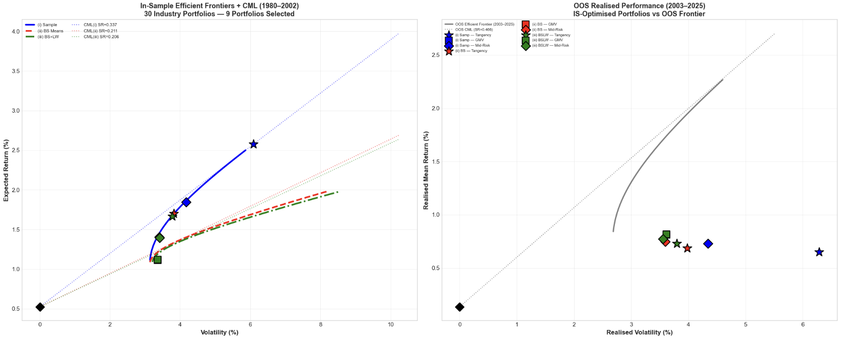Figure 4: In-Sample vs Out-of-Sample Efficient Frontier – 30 Industry Portfolios
In the figure 4, the tangency portfolios decline heavily in Sharpe ratio during the out-of-sample period. This reflects overfitting to noisy mean estimates in the first period, a phenomenon commonly referred to as estimation error. However, the GMV portfolio states greater stability across subperiods, as it relies primarily on the covariance matrix rather than expected returns, which are more difficult to estimate accurately. The Jobson–Korkie (1981) and Ledoit–Wolf (2008) tests are conducted to identify whether differences are statistically significant and the result shows that the gaps are not statistically strong.
Overall, the results in this section prove that the importance of evaluating portfolio using out-of-sample validation rather than relying solely on in-sample efficiency in real-world practice.

Bibliography
Fama, E. F. & French, K. R. (1993). Common Risk Factors in the Returns on Stocks and Bonds. Journal of Financial Economics, 33(1), pp.3–56. Available online: https://doi.org/10.1016/0304-405X(93)90023-5 [Accessed: 13th February]
Fama, E. F. & French, K. R. (2015). A Five-Factor Asset Pricing Model. Journal of Financial Economics, 116(1), pp.1–22. Available online: https://doi.org/10.1016/j.jfineco.2014.10.010 [Accessed: 14th February]
Chopra, V.K., Hensel, C.R. and Turner, A.L., 1993. Massaging mean–variance inputs: Returns from alternative global investment strategies in the 1980s. Management Science, 39(7), pp.845–855. Available online: https://www.jstor.org/stable/2632423?seq=1 [Accessed: 15th February]
Jobson, J.D. and Korkie, B.M., 1981. Performance hypothesis testing with the Sharpe and Treynor measures. Journal of Finance, 36(4), pp.889–908. Available online: https://go.exlibris.link/8cWfT7b0 [Accessed: 14 February]
Ledoit, O. and Wolf, M., 2008. Robust performance hypothesis testing with the Sharpe ratio. Journal of Empirical Finance, 15(5), pp.850–859. Available online: https://go.exlibris.link/hlMLKKz9 [Assessed: 15 February]
Michaud, R.O., 1989. The Markowitz optimization enigma: Is “optimized” optimal? Financial Analysts Journal, 45(1), pp.31–42. Available online: https://www-jstor-org.ucd.idm.oclc.org/stable/4479185?seq=1 [Accessed: 15th February]

